**Guide for building alternative imputation functions**

Nearest neighbor (k=1) is the default function for imputing FMLA leave taking behavior into the ACS. To call other imputation methods, there is an optional user parameter “impute_method” that is meant to swap out NN with another function. This is a description of how to make an alternative method compatible with this set up.

Step 1. Add a label for “impute_method” to recognize:

The “impute_method” parameter is passed through to “impute_fmla_to_acs” (subfunction 5, "2_NEW_impute_functions.R"). Lines 619-636 run the KNN1 imputation function if impute_method==”KNN1”.

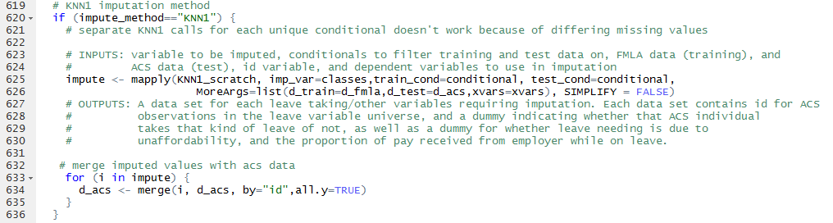

Step 2. Additional imputation methods should be called directly below this in a similar if statement. For example:



Anything can be called to perform an imputation method without any further modifications to other parts of the code under the following constraints:

1. No additional user inputs are needed beyond what is already called by the “impute_fmla_to_acs” function. If further inputs are required, they can be added to the “impute_fmla_to_acs” and “policy_simulation” arguments lists.

d_fmla - modified fmla data set

d_fmla_orig - unmodified fmla data set

d_acs - ACS data set

leaveprogram - TRUE or FALSE. Presence or absence of a leave program.

impute_method - method to use for imputation

xvars - dependent variables used by imputation method. Must be present and have same name in both fmla and acs data sets.

1. Imputation method expects FMLA/ACS data in its current format as inputs. Copies of the data frames to expect as inputs are saved as “d_fmla_impute_input.rds" and

"d_acs_impute_input.rds" when the program is run.

1. Imputation method outputs ACS data with the standardized format expected by the next step of the function. The output data set the next step of the program expects (and which the imputation method should produce) is saved as "d_acs_impute_output.rds".

Essentially, the output ACS data set should be the exact same format as the input data set, except the following columns should be added from the FMLA survey to the ACS data set in some fashion:

* 1. unaffordable
  2. prop_pay
  3. take_bond
  4. take_matdis
  5. take_illparent
  6. take_illchild
  7. take_illspouse
  8. take_own

